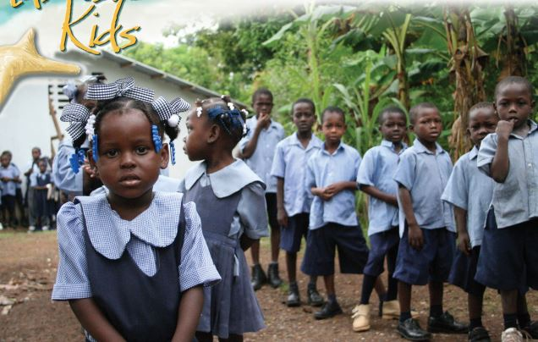
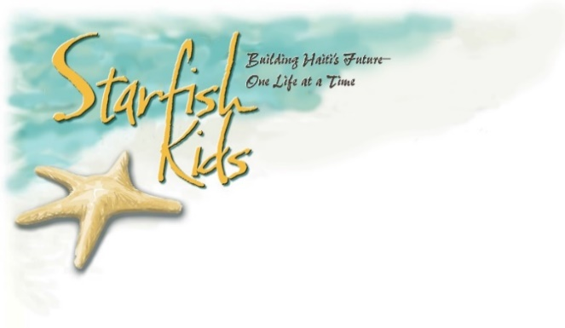
Mission: The Starfish Kids Program is a child evangelistic ministry which combines sponsorship with education to deliver the good news of the Gospel. There are approximately 800 children who are sponsored and receive school books, paid tuition and Gospel teaching through the Starfish Kids Program in 30+ established Emmaus Fellowship of Churches schools. The donors are from USA, Canada and the UK. Sponsored children are required to attend church and because of this, many of their families attend as well.
History: The Starfish Kids Program in Haiti was started in 2002 in response to a request by the Emmaus Fellowship of Churches, the church associated with One Mission Society in Haiti.
Three people met to outline the program: Pastor Dulceine Joseph, representative of the Emmaus Fellowship of Churches; Eutrope Samson, long-time employee in various ministries of OMS Haiti; Joetta Lehman, OMS Haiti missionary. An OMS Canada missionary in Haiti, Gill Shoemaker became in charge of the program working with the Emmaus Fellowship of Churches and other missionaries.
Today: The USA and Canada coordinators have, along with the Haitian staff, been working diligently together to move the Starfish Kids Program forward to new levels of accuracy, accountability and growth. New monthly attendance sheets have been established at all schools, as well as increased communications with the Haitian staff. Information flow and documentation between USA, Canada and Haiti has resulted in more timely and accurate information for donors, the children, the field and the coordinators.
How YOU can help: Pray; for the Starfish Kids program and its growth, the children, their families, the OMS Starfish Kids team. Pray that God would continue to use the Starfish Kids program for His glory as we see children grow and even flourish into beautiful examples of God’s grace. Prayer changes everything!! Sponsor; we currently have 100+ children waiting to be sponsored. You could help to make a difference in the life of a child and perhaps their family and community, today! Go; be part of a short term team and visit the children (even your child) in their schools, the churches and the OMS compound in Haiti.
Sponsorship is just $25 per month. You really can make a difference—one child at a time. If you'd like to be matched with a sponsor child, please contact us at starfishkids@onemissionsociety.org. We have a child waiting for you that needs your help.

Gwen Pinkerton Cheryl Muirhead
Starfish Kids Program Coordinator – USA Starfish Kids Program Coordinator - Canada
gpinkerton@onemissionsociety.org cmuirhead@omscanada.org
www.onemissionsociety.com www.omscanda.org

Thank you for helping win Haiti one child at a time
starfishkids@onemissionsociety.org

